1. ***What is JQuery*?**

* JQuery is an inbuilt library of the JavaScript.
* JQuery is use to make easier to use JavaScript on website.
* JQuery simplified the complicated things of JavaScript.
* The basic syntax of JQuery is $(selector).action ().

1. ***How to Apply CSS Using JQuery, How to Add Class and Remove Class in JQuery, JQuery Animation?***

***How to Apply CSS Using JQuery:***

* To apply CSS using JQuery “css()” is used.

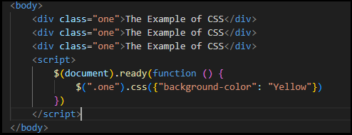

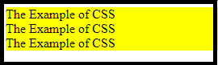

***How to Add Class and Remove Class in JQuery:***

* ***addClass ():*** method is use to add one or more classes to the elements.

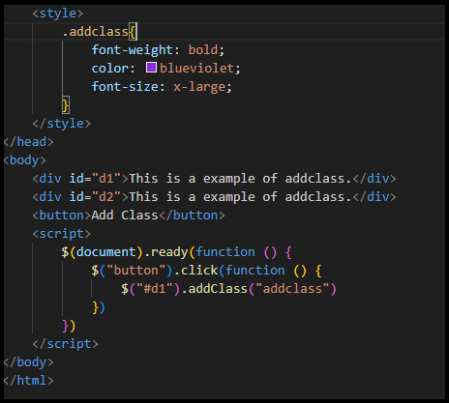

***Output:***

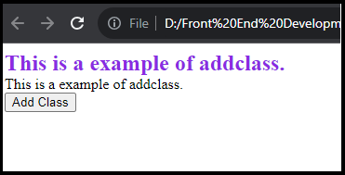

* ***removeClass ()****:* method is use to remove one or more classes to the elements.

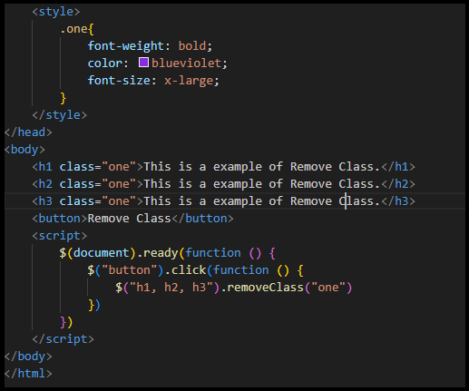

***Output:***

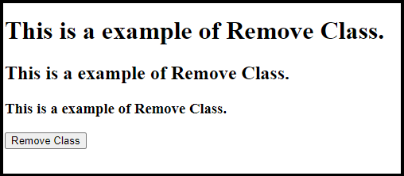

***JQuery Animation:***

* The **animate ()** method is use to create animations in JQuery.

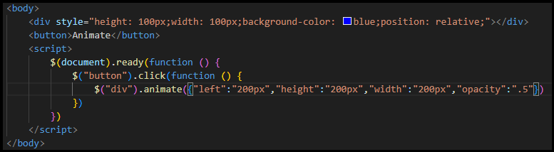

***Output:***

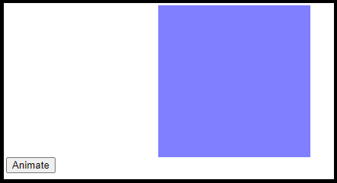

1. ***How to create slider with animation?***

* We can create slider with following slide methods:
* ***slideDown ():*** This method is use to slide down an element.

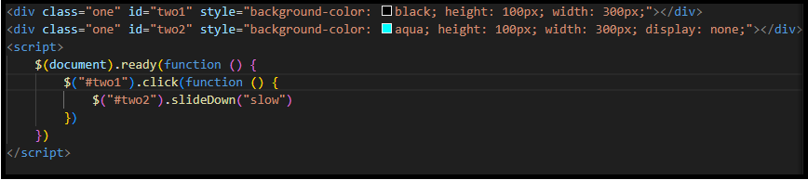

* ***slideUp ()*** : This method is use to slide up an element.

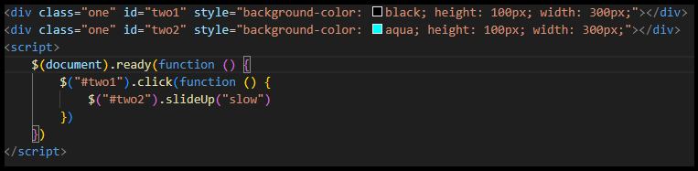

* ***slideToggle():*** This method to slide both up and down an element

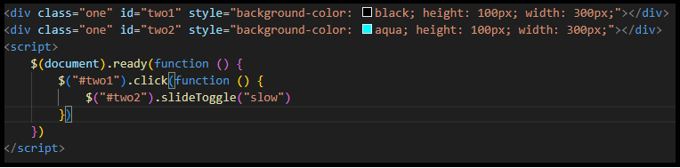

1. ***Event bubbling tickling example***:

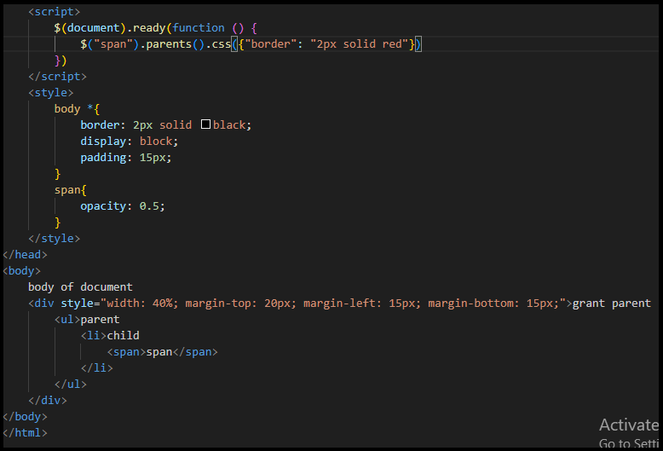

***Output:***

